1. **Overview of website:**

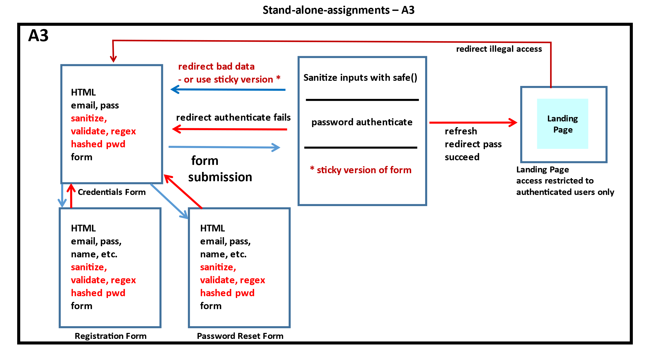

1. **List of functions:**

* **$_SESSION []:** session array allows to pass variable values to multiple files.
* **hash ():** hash function will generate hashed password for security purpose.
* **password_verify ():** Boolean function will verify clear text password against hashed password and return True or False.
* **filter_var_sanitize ():** sanitized user input. function will remove any illegal character from user input.
* **filter_var_validate ():** function check if user input is valid type or not.
* **preg_match_regex ():** function check if user input follows the given pattern or not.
* **mail ():** http function use to send email to given email address.
* **array_key_exiest():** check weather button got clicked or not. (by POST or GET method).